**Proposed development at Willow-Pfingsten intersection heads for third Glenview Plan Commission public hearing**

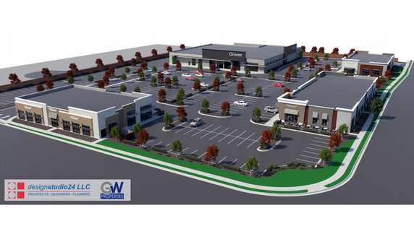

*Glenview’s Plan Commission will hear a proposal from developer GW Properties for a project consisting of four single-story buildings totaling up to 63,600 square feet of new retail and restaurant space. Renderings courtesy of the Village of Glenview/GW Properties*

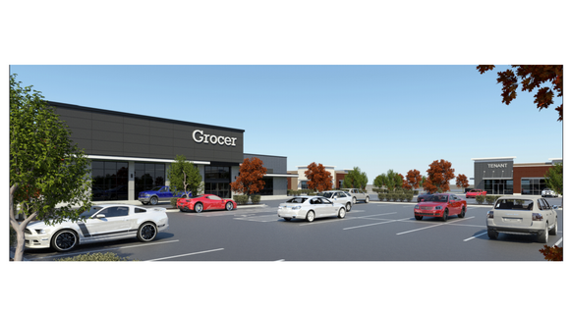

Chris Pullam, Freelance Reporter

3:00 am CDT September 12, 2019

A second three-hour Glenview Plan Commission meeting, which again included more than an hour of public comment time, still wasn’t enough to unpack the details of a proposed development at the Southwest corner of Willow and Pfingsten roads.

During its Aug. 27 meeting, the Glenview Plan Commission unanimously voted to continue the discussion until its Tuesday, Sept. 10 meeting in order to further flush out the proposal. Specifically, both the commission and the developer, GW Properties, hoped to walk residents through the results of a traffic-impact study, which GW Properties claimed should calm residents’ concerns that the project would hinder drivability in the area.

Still, a boardroom packed with residents opposed to the development led the Plan Commission to schedule a third meeting for Thursday, Sept. 26, to continue the discussion.

Currently, the 8.5-acre subject property holds a two-story, single-family residence and several accessory buildings.

As proposed, the development would replace those structures with several commercials buildings located on the north 6.2 acres of the site, including a 35,000-square-foot grocery store and multi-tenant retail buildings totaling 28,600 square feet. The project would also include six new single-family homes, served by a proposed extension of Charlie Court, on the south 2.352 acres.

Although the development plans discussed on Sept. 10 were “substantially consistent with the original development plans” pitched during the August meeting, GW Properties did make several tweaks, according to Glenview Planning Manager Jeff Rogers.

Those changes include shifting 300 square feet of proposed retail space between two buildings, modifying the location of underground storm sewers to preserve mature trees, and moving one of the trash enclosures to a more internal location on the site.

None of the changes directly impacted residents’ chief concern: how the development would impact traffic.

“Traffic at Pfingsten and Willow is very, very bad,” Glenview resident Jerry Tivers said. “Now we’re talking about cuts and changes, and things are just going to get worse, and just so we can have a development that nobody in this room seems to want.

“If we want something to bring in money, why don’t we have a gentleman’s club or a permanent circus,” he said in jest, “both which would bring in more money.”

According to Rogers, traffic studies indicate that approximately 36,000 vehicles use Willow Road each day, even though an IDOT study suggests a maximum capacity of 34,000 vehicles, meaning that current traffic already exceeds the intended use by 2,000 cars daily.

To accommodate the daily use, Willow Road would need to be expanded to three lanes in each direction, to enable the road to handle up to 50,000 cars each day. Upcoming IDOT improvements wouldn’t expand Willow Road from its current two lanes.

They would, however, add two new deceleration right-turn lanes on Willow road in both directions at the Pfingsten Road intersection, which will help ease some traffic burdens in the area of the proposed development.

According to Rogers, however, current and future traffic density has little impact on how the Plan Commission can assess the development, since use of public roads isn’t predicated on a first-come, first-served basis.

“Just because there is a lot of existing traffic on Willow and Pfingsten, that is not a sufficient reason to deny the development of vacant property,” Rogers said. “All property owners are provided the right to use and access public rights of way.”

However, some residents took traffic congestion a step forward to voice concerns about an increased potential for traffic accidents.

“I’ve heard a very sanitized report here tonight about traffic and anecdotal events and data and statistics,” Glenview resident Jerome Orbach said. “Maybe we want to humanize that a little bit. I live on Charlie Court, and for years we had a young man on Charlie Court — a boy, a terrific young man — he was a scout from his head to his heart to his feet to his hands. If he had packages to carry, he would volunteer to carry your packages.

“He was an angel, an absolute angel. On February 22 of ‘05, this young man rode his bicycle outside the safe confines of Charlie Court and was killed on the corner of Pfingsten and Willow [after being struck by a car]. The next time I saw him was at the Scott Funeral Home.”

According to traffic-engineering consultant Kenig, Lindgren, O’Hara, Aboona, which was hired by GW Properties to conduct a traffic-impact study regarding the proposed development, there are currently 1.15 crashes per every 1 million vehicles that approach the intersection. An estimated 48,050 vehicles pass through the intersection each day.

While the proposed development would generate approximately 3,600 daily two-way trips, leading to an estimated .78 percent increase in crashes, that number would be offset by an undetermined percent by IDOT’s pending improvements at the intersection.

For comparison, the intersection of Lake Avenue and Waukegan Road, which services 46,650 vehicles per day, experiences 2.71 crashes per million vehicle approaches. The Willow Road and Patriot Boulevard intersections, with 50,100 daily vehicles, experiences 1.34 crashes per million.

While some residents contested that the studies weren’t conducted at peak times, Luay Aboona, principal with KLOA, said that they were conducted in accordance with IDOT regulations that ensure all data is comparable.

He also told the crowd that while the proposed development could generate 3,600 daily trips, some will come during off-peak hours when traffic is light, and many of the trips during peak hours will come from commuters who were already driving past the site as part of their normal route.

“Still, it’s important to know that any new development will create traffic,” Aboona said. “There is no doubt that there will be traffic generated by this development compared to what is there now. Commercial developments want to be at nodes and intersections where there is high volume of traffic because they rely on that traffic for their business and visibility.”

Mitch Goltz, principal of GW Properties, took time to address another chief concern: whether vehicles will back up and potentially make turns in reverse while in front of the proposed grocery store. According to Goltz, that setup isn’t in GW Property Group’s plans.

“Our full intention with loading the grocer onsite is to come from Willow Road,” he said. “We did do the test exercise to show how that would take place off Pfingsten, but we don’t intend that trucks would be coming from Pfingsten. … Again, backing up in front of the store is not ideal for anybody, and it’s definitely not our intent.”

The Glenview Plan Commission will reopen the discussion during its Thursday, Sept. 26 meeting. Eventually, the Plan Commission will pass a recommendation for approval or denial to the Glenview Village Board, which will then take a preliminary and final vote.